**INTELLIGENT CUSTOMER RETENTION: USING MACHINE LEARNING FOR ENHANCED PREDICTION OF TELECOM CUSTOMER CHURN**

*Customer churn is often referred to as customer attrition, or customer defection which is the rate at which the customers are lost.*

INTRODUCTION

* *Customer churn is a major problem and one of the most important concerns for large companies.*
* *Due to the direct effect on the revenues of the companies, especially in the telecom field, companies are seeking to develop means to predict potential customer to churn.*
* *Telecommunication industry always suffers from a very high churn rates when one industry offers a better plan than the previous there is a high possibility.*

TECHNICAL ARCHITECTURE: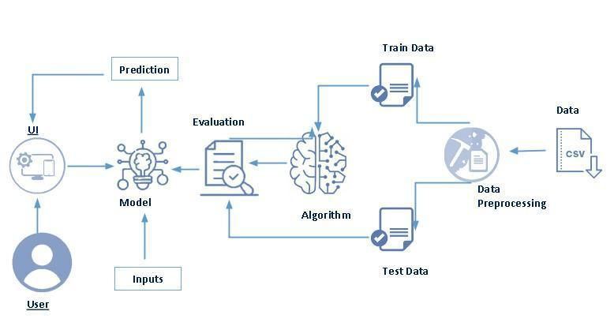

PROJECT FLOW:

User interacts with the UI to enter the input.

* Entered input is analysed by the model which is integrated.
* Once model analyses the input the prediction is showcased on the UI.
* To accomplish this,we have to complete all the activities listed below,

## Define problem/problem understanding

* Specify the business problem
* Business requirements
* Literature survey
* Social or Business impact.

## Data collection & Preparation

* Collection of Dataset
* Data preparation

## Exploratory Data Analysis

* Descriptive statistical
* Visual analysis

## Model Building

* Training the model in multiple algorithms
* Resting the model

## Performance Testing & Hyperparameter Tuning

* Testing model with multiple evaluation metrics
* Comparing model accuracy before & after applying hyperparameter tuning

## Model Deployment

* Save the best model
* Integrate with Framework

## Project Demonstration & Documentation

* Record explanation video for project end to end solution
* Project Documentation-step by step project development procedure

PROJECT STRUCTURE:

Create a project folder which contains files as shown below

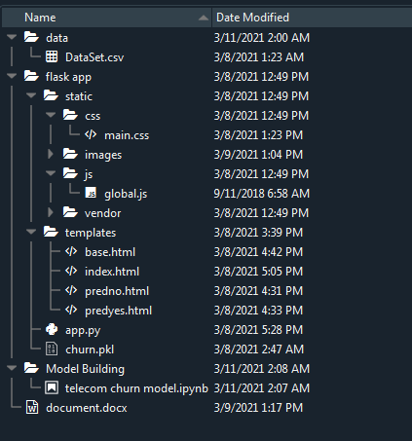

* A python file called app.py for server side scipting.
* We need the model which is saved and the saved model in this content is churn.pkl
* Templates folder which contains base.HTML file, index.HTML file,predyes.HTML , predno.HTML file.
* Static folder which contains css folder which contains main.css , js folder which contains global.js , images folder and vendor folder.